Geography  Where is Egypt located? How did the ancient Egyptians adapt to their environment?  Religion  Beliefs, Polytheistic? Rituals? | - Egypt is located on the continent of Africa.  - The climate in ancient Egypt is very hot and dry.  - The ancient Egyptians farmed and irrigated the land near the Nile River. The Nile River flows north into the Mediterranean Sea.  - The Nile River was used by the ancient Egyptians for many things. They fished for food, washed themselves and their clothes, and collected water for irrigation, drinking and cooking. They also traveled by boat around Egypt and into the Mediterranean Sea to trade with other cultures.  - The land in Egypt is about 90 percent desert. There are grasses along the Nile River. The Nile River floods every year. This flooding brings in rich soil for planting.  - The ancient Egyptians were polytheistic, meaning they believed in many gods.  - Main gods was the sun god, Ra. Others important gods: Isis, Osiris, Anubis, Horus  - Their gods often had animal heads and human bodies.  - Many Pharaohs built large temples in honor of their gods. These temples would have large statues, gardens, memorials, and a place of worship.
Achievements  A contribution is the act of giving or doing something.  Many of the ancient Egyptians inventions are used today.  Political/Government  Who ruled in ancient Egypt? | - The ancient Egyptians used hieroglyphics as their written language. Hieroglyphics is writing using pictures to represent different sounds.  - The Egyptians created the clock and the 365-day calendar we use today.  - One of the most remarkable architectural structures from ancient Egypt is the pyramids.  - Papyrus – used to make writing material, boats, mats & other things.  - Shipbuilding made from papyrus reed and then wood & Math – applied geometry to determine land boundaries and to build pyramids. They had to measure area, volume, etc.  - The ancient Egyptians were ruled by Pharaohs.  - Pharaohs were the highest level in ancient Egyptian society.  - When a pharaoh died, he would be buried in a tomb or pyramid with all of his valuables. The Egyptians mummified their pharaoh. It was believed that they would need these things in the after-life.  - Cats were considered good luck.
Economics  What did the ancient Egyptian people use to buy and sell goods and services? | - The ancient Egyptians traded with other cultures like ancient Rome and Greece.  - The used papyrus to make paper, mats, boats, etc.
Social Structure  How was society? Higher class? Lower class? Jobs? Women/men? | - Hierarchy system:  - Men were in charge of family but women were important in Egyptian society, more so than most other ancient cultures.  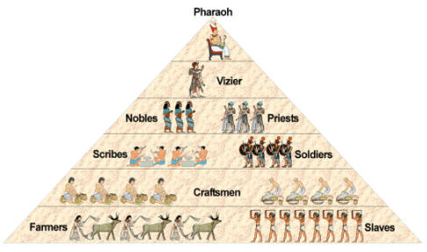  - Jobs: scribes, jewelers, potters, carpenters, farmers, soldiers, priests, government officials,
http://www.fcps.edu/KingsParkES/technology/ancient/egypt.htm#ecomonics

