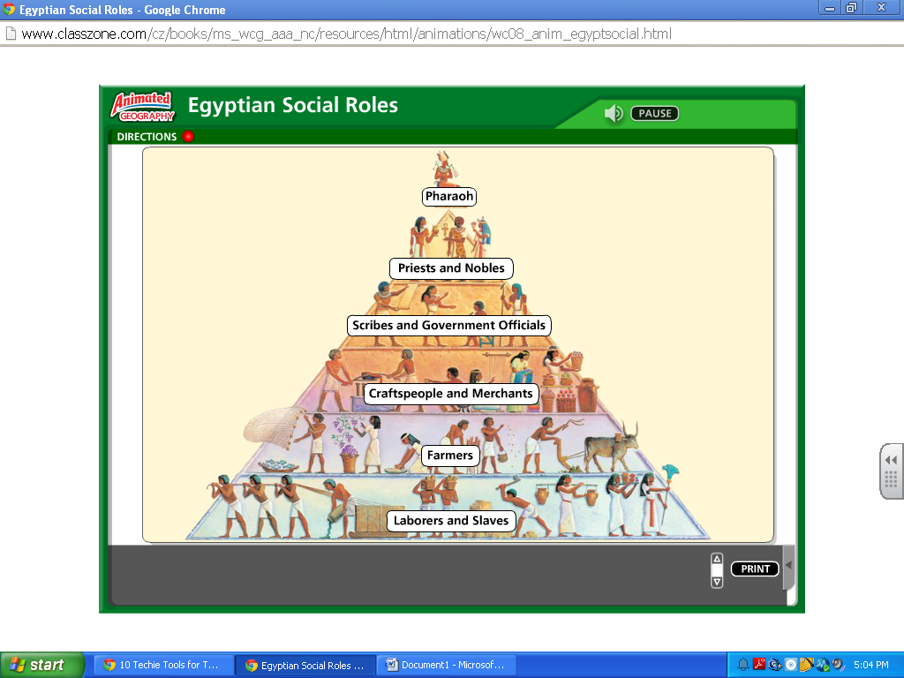

**Priests: cared for temples and held ceremonies to keep gods happy.**

**Pharaoh: Ruler who was above all people and was considered a god.**

**Scribes: Trained to write hieroglyphic and keep records.**

**Government officials: keep things running for pharaoh.**

**Slaves: usually the poor who owed a debt, committed a crime, or captured in war.**

**Merchants/artisans: Producers of goods such as fabrics, tools, jewels, etc. They exchanged goods through the barter system instead of using money.**