EDIT ************** EDIT****************EDIT***************EDIT********
Vocabulary Japan Unit
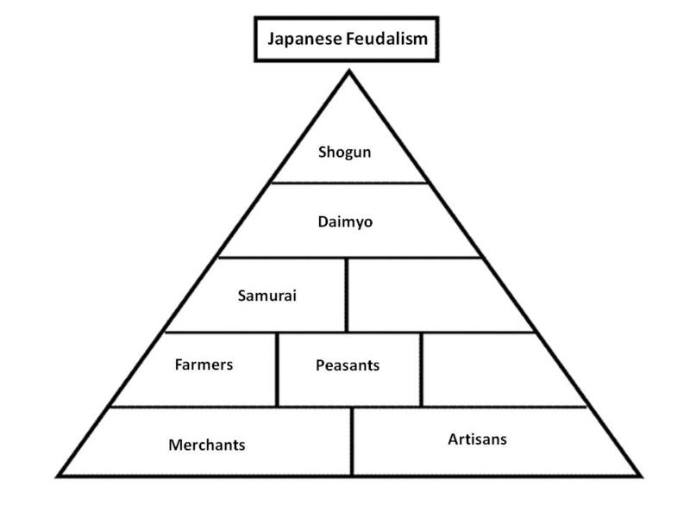
- Feudalism - A government in Japan with a chain of service and protection. The samurai worked for the shogun or daimyo. (who was under the emperor)
- Shogun: Supreme general of the emperor’s army in Japan, sometimes more powerful than the emperor
- Samurai: Loyal warrior bodyguards who protected feudal lords in Japan
- Bushido: Samurai code of behavior. “Way of the warrior”
- Abolish: put an end to or get rid of
- Shinto: the native religion of Japan, based on respect for the forces of nature and on the worship of ancestors

- Take out Daimyo?????????????
- ***Daimyo [Dime-yaw]: feudal warlords who owned and controlled land (served under the shogun). (Samurai gone rogue; sometimes a samurai went out on their own and built their own army instead of serving under the Shogun )

EDIT ************** EDIT****************EDIT***************EDIT********
Take out daimyo or shogun

Vocabulary Japan Unit
- Feudalism - A government in Japan with a chain of service and protection. The samurai worked for the shogun or daimyo. (who was under the emperor)
- Shogun: Supreme general of the emperor’s army in Japan, sometimes more powerful than the emperor
- Samurai: Loyal warrior bodyguards who protected feudal lords in Japan
- Bushido: Samurai code of behavior. “Way of the warrior”
- Abolish: put an end to or get rid of
- Shinto: the native religion of Japan, based on respect for the forces of nature and on the worship of ancestors
- Daimyo [Dime-yaw]: feudal warlords who owned and controlled land (served under the shogun). (Samurai gone rogue; sometimes a samurai went out on their own and built their own army instead of serving under the Shogun )

