Ancient Rome Entertainment
Teacher Overview

The Forum was the main marketplace and business center. Ancient Romans would go to the forum do their banking, trading, and shopping. It was also a place for public speaking. People in the forum would stop and listen to public speakers, then wander away to do their shopping. The Forum was also used for festivals and religious ceremonies. It was a very busy place.
The Colosseum was a huge public entertainment center. It could seat 45,000 spectators. This is where the ancient Romans gathered to watch bloody fighting between gladiators, and battles between men and wild animals. Sometime they even flooded the Colosseum with water to hold naval battles. During the battles, many competitors died.
The Public Baths were extremely popular. Roman women and men tried to visit the baths at least once every day. The baths had hot and cold pools, towels, slaves to wait on you, and hair cutting salons. They even had stores, selling all kinds of things. People sold hot fast food. The baths were like a very large mall with bathing pools.
The ancient Romans loved chariot racing. The ancient Romans built the Circus Maximus in Rome. It was a big race track for racing chariots. It was first built from wood and then rebuilt using marble and concrete. It could seat over 250,000 people and it was free to attend. There were races every day.
The Romans loved live theatre. Plays were only performed during religious festivals. When it came time to have a play, a wooden platform was built in the forum for the actors to perform on. The actors were all men. The actors held up happy face masks and sad faced masks, to help the audience understand what was going on in the play.
In the city, there was a place called the Campus. It used to be used by soldiers. It was a large section of plain near the Tiber River. Over time, the Campus became ancient Rome's field and track playground. Young men, all over Rome, gathered at the Campus to play and exercise. Men participated in foot racing, jumping, archery, wrestling and boxing.
There were impressive temples all over the Roman Empire. Every day, the ancient Romans brought offerings of meat and other items to at least one nearby temple. Usually they visited more than one temple every day. One of the most famous temples was the Pantheon. It had a dome for its ceiling.

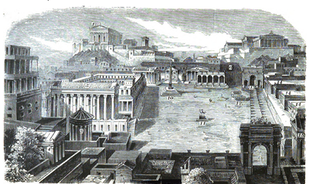

The Forum was the main marketplace and business center. Ancient Romans would go to the forum do their banking, trading, and shopping. It was also a place for public speaking. People in the forum would stop and listen to public speakers, then wander away to do their shopping. The Forum was also used for festivals and religious ceremonies. It was a very busy place.

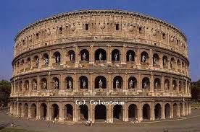

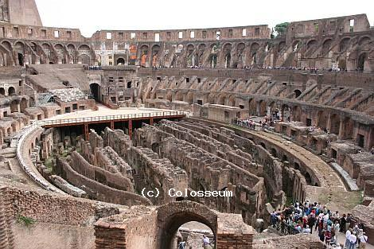

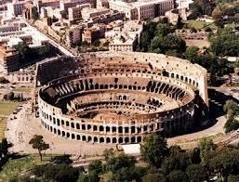

The Colosseum was a huge public entertainment center. It could seat 45,000 spectators. This is where the ancient Romans gathered to watch bloody fighting between gladiators, and battles between men and wild animals. Sometime they even flooded the Colosseum with water to hold naval battles. During the battles, many competitors died.

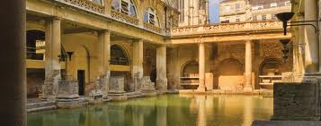

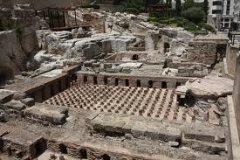

The Public Baths were extremely popular. Roman women and men tried to visit the baths at least once every day. The baths had hot and cold pools, towels, slaves to wait on you, and hair cutting salons. They even had stores, selling all kinds of things. People sold hot fast food. The baths were like a very large mall with bathing pools.

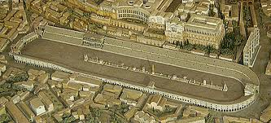

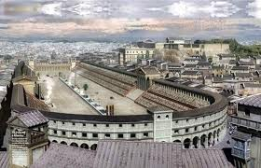

The ancient Romans loved chariot racing. The ancient Romans built the Circus Maximus in Rome. It was a big race track for racing chariots. It was first built from wood and then rebuilt using marble and concrete. It could seat over 250,000 people and it was free to attend. There were races every day.

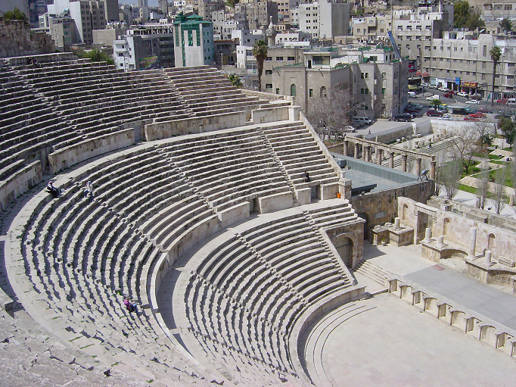

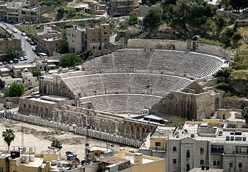
The Romans loved live theatre. Plays were only performed during religious festivals. When it came time to have a play, a wooden platform was built in the forum for the actors to perform on. The actors were all men. The actors held up happy face masks and sad faced masks, to help the audience understand what was going on in the play.

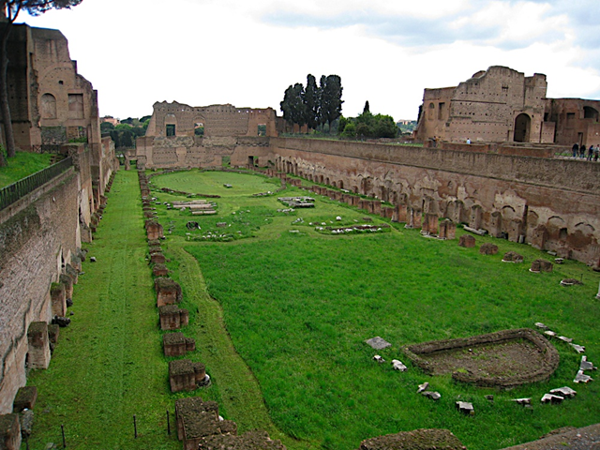

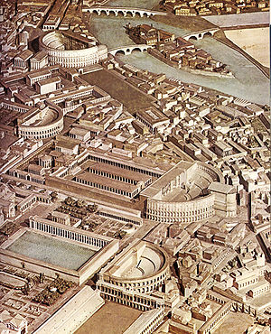

In the city, there was a place called the Campus. It used to be used by soldiers. It was a large section of plain near the Tiber River. Over time, the Campus became ancient Rome's field and track playground. Young men, all over Rome, gathered at the Campus to play and exercise. Men participated in foot racing, jumping, archery, wrestling and boxing.

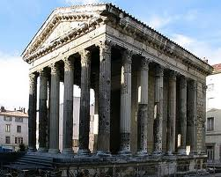

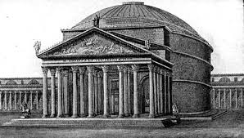

There were impressive temples all over the Roman Empire. Every day, the ancient Romans brought offerings of meat and other items to at least one nearby temple. Usually they visited more than one temple every day. One of the most famous temples was the Pantheon. It had a dome for its ceiling.

The Temples
Where were they?________________________
What is the most famous temple? ________
____________________________________
What was special in the ceiling of this temple? _______________________________
How often did they did they visit a temple? _______________________
The Forum
What was the forum? _________________________
___________________________________________
Ancient Romans would go to the forum to do their ___________________________________________
The Forum was also a place for _________________ speaking.
The Forum was also used for festivals and ___________________________________________
What did we discuss that was similar to this with the Greeks? ___________________________________

The Colosseum
What was it? _________________________
____________________________________
How many people could sit in the Colosseum? __________________________
What did the Ancient Romans watch here?
____________________________________
____________________________________
____________________________________
Sometimes the Romans even _____________ the Colosseum with ____________ to hold naval battles.

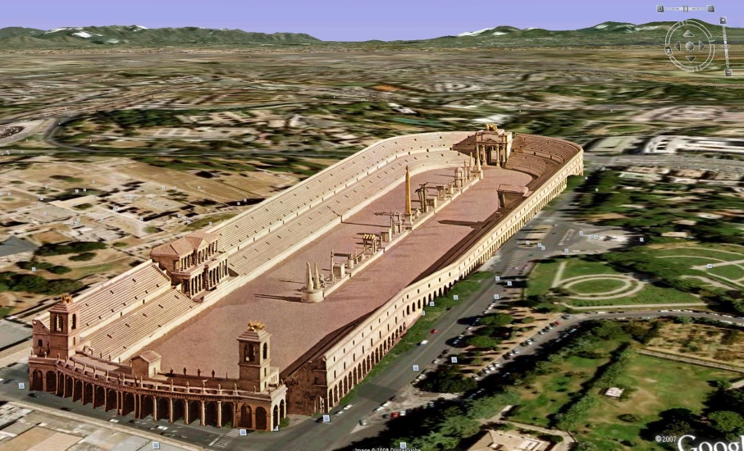

Circus Maximus
What was the Circus Maximus? _______________________________________________________
_________________________________________________________________________________
How many people could it seat?____________________________ __________________________
What did the Ancient Romans watch here? _____________________________________________
This track was first built from wood and then rebuilt using ____________ and _____________________
____________________________________
____________________________________
____________________________________

The Theatre
Romans loved live theatre. Plays were only performed during ___________________________
Where was the wooden platform built for plays? ______________________________________
Like with the Greeks, who performed in the Roman plays? __________________
The actors held up happy or sad _______________ to help the audience understand the play.

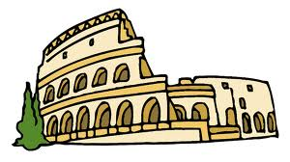

The Public Baths
True/False (circle one) The Public Baths in Rome were very popular.
How often did the Romans visit the baths? ____________________
_______________________________________________________
List three things that could be found at the baths. _______________
_______________________________________________________
_______________________________________________________
The Roman baths even had _______________ for ________________ all kinds of things. The baths were like a large _________________ with bathing pools.

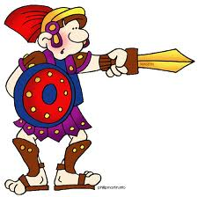
The Campus
Who used to use the Campus? _______________
_________________________________________
What river was the Campus near? ______________
Over time, the Campus became Rome’s field and ______________ playgrounds.
The men gathered at the Campus to play and ______________________.

Ancient Rome Postcard
You have just spent the day visiting Ancient Rome! You were able to visit many of the most popular places in Rome and you learned a lot about the Roman culture. Write a postcard to your best friend and describe your day. You should mention at least two places you visited and what you did at those places. When you are finished, cut out your postcard and design the front with a picture of where you Ancient Rome.
