Create your own Japanese Fan
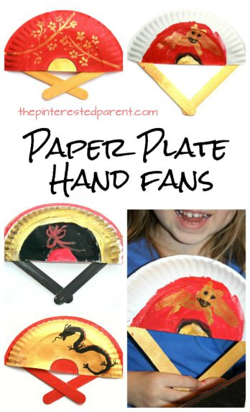
JAPANESE FANS are made of paper on a bamboo frame, usually with a design painted on them. Designs often show scenes from nature such as trees, mountains, or animals. In addition to folding fans (ōgi), the non-bending fans (uchiwa) are popular and commonplace. The fan is primarily used for fanning oneself in hot weather.
The fan symbolizes friendship, respect and good wishes. They are given on special occasions, and they are also an important stage prop in Japanese dance.
You will be creating your own Japanese Fan. Follow the steps below to create your fan.

Side 1: Draw a large picture or several small pictures that represent Ancient Japan and color it.
Side 2: Choose one of the following options
Option 1: Write an acrostic poem for JAPAN
Option 2: Write 7 facts about Japan
***After creating the fan, glue a craft stick to it for the handle.
Now you have your own Japanese Fan!
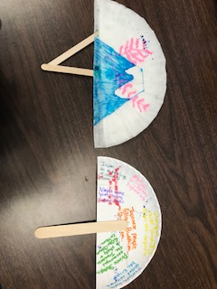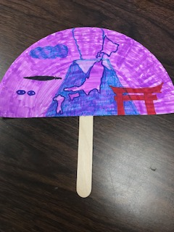

Possible pictures:
