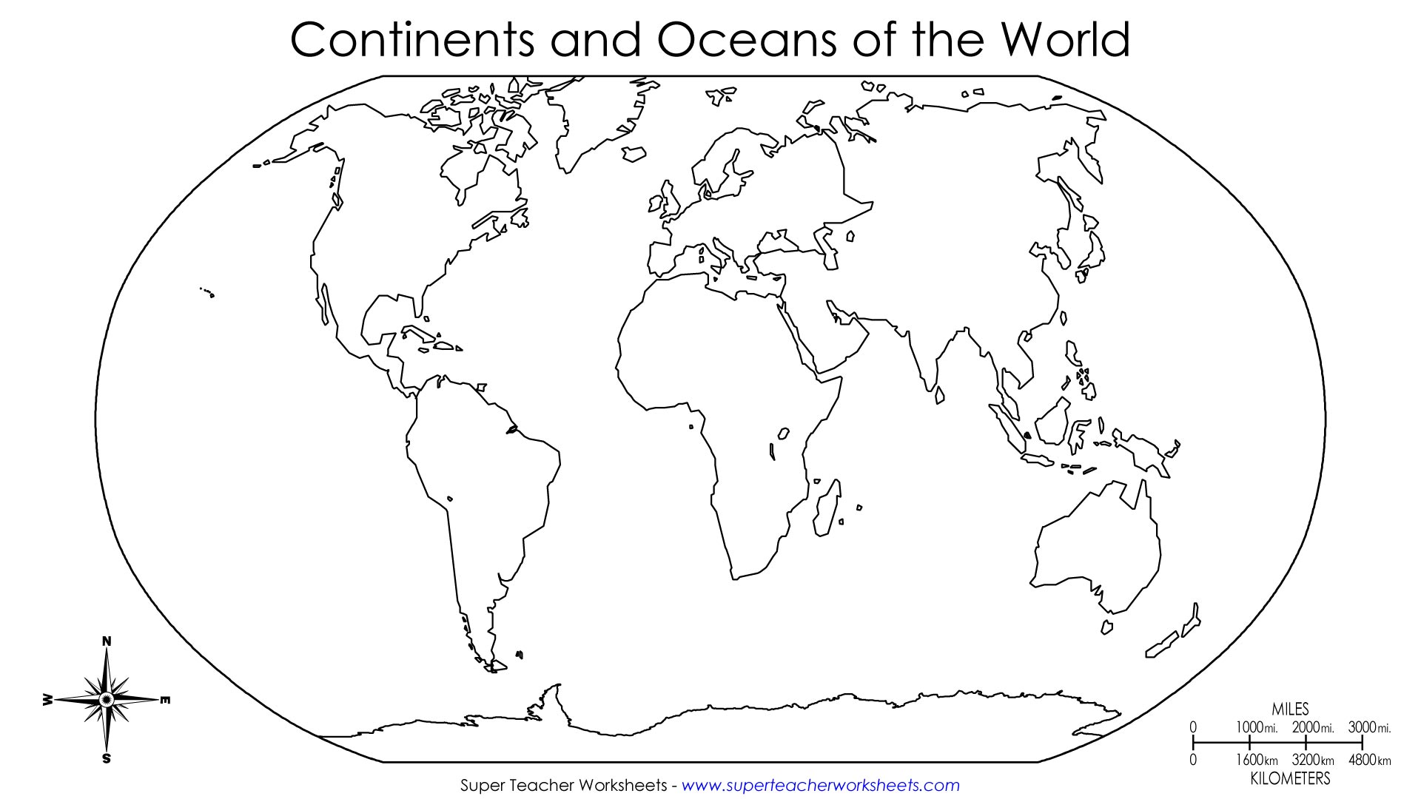

1. Label all 7 Continents (Use map for help)
2. Label all 5 Oceans
3. Outline all continents with the correct color (listed below) or outline it with pen/marker.
4. Lightly Color North America RED with colored pencil.
5. Lightly Color South America GREEN with colored pencil.
6. Lightly Color Antarctica PURPLE with colored pencil.
7. Color Africa ORANGE with colored pencil.
8. Color Australia YELLOW with colored pencil.
9. Lightly Color Asia BLUE with colored pencil.
10. Lightly Color Europe BROWN with colored pencil.
***Finish labeling the compass rose.

